HARROW COUNCIL

ADDENDUM AND SUPPLEMENTAL ADDENDUM

PLANNING COMMITTEE

DATE : 22ND June 2022

2/06 | 34 Woodlands Road – P/0177/22  - Remove Condition 4 within Appendix 1  - Add new Informative No.8 as follows:  ‘INFORMATIVE: The applicant is advised that notwithstanding the approved plans, the development hereby permitted showing the full removal of the upstand walls in brick and the beam spanning between these walls shall be carried out and completed in full accordance with Dwg No: PL-DR-EX-XX-70 within three months of the date of this decision. Failure to comply could result in Enforcement action.

2/03 | Comment: The attached drawings are the elevations of the granted scheme (P/3667/19), the refused scheme (P/3522/21) and the current proposal (P/0352/22 and P/0451/22).  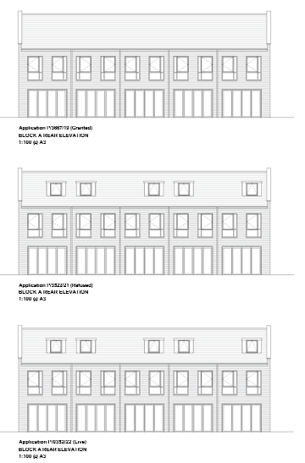

 | 2/04 | Comment: The attached drawings are the elevations of the granted scheme (P/3667/19), the refused scheme (P/3522/21) and the current proposal (P/0352/22 and P/0451/22).  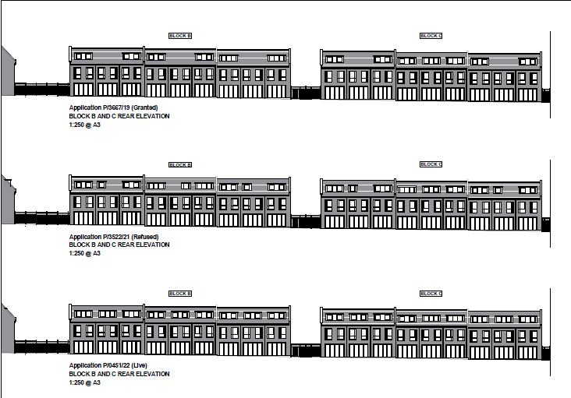
 | 1/01 | At Paragraph 6.11.3 this is amended to read:  The applicant has submitted a fire strategy report during the determination period of the application, this is subject to HSE review. This application will not be granted planning permission until this review has taken place, and no objection is received from the HSE. A condition (34) shall be imposed to ensure details of fire safety are submitted to and approved in writing by the Council in order for the building to be managed in a satisfactory manner prior to the commencement of the development.  At Appendix 1 – the addition of Condition 34 - pre-commencement condition for fire safety.  The condition reads:  Prior to the commencement of the development hereby approved, a Fire Safety Statement shall be submitted to and approved in writing by the Local Planning Authority, this statement shall include details of how the development will function in terms of the following:  1) identify suitably positioned unobstructed outside space: a) for fire appliances to be positioned on b) appropriate for use as an evacuation assembly point  2) is designed to incorporate appropriate features which reduce the risk to life and the risk of serious injury in the event of a fire; including appropriate fire alarm systems and passive and active fire safety measures  3) is constructed in an appropriate way to minimise the risk of fire spread  4) provide suitable and convenient means of escape, and associated evacuation strategy for all building users  5) develop a robust management strategy for evacuation which is to be periodically updated and published (details of how often this management strategy is to be reviewed and published to be included), and which all building users can have confidence in  6) provide suitable access and equipment for firefighting which is appropriate for the size and use of the development.  The development shall be operated in accordance with the approved details in perpetuity.  REASON: To ensure that the fire safety of the proposed building is managed in a satisfactory manner and that the development contributes to fire safety in line with Policy D12A of the London Plan (2021). To ensure appropriate fire safety measures are approved before development commences on site, this condition is a PRE-COMMENCEMENT condition.
AGENDA ITEM 10 – REPRESENTATIONS ON PLANNING APPLICATIONS

Agenda Item |  |  | Application | Speakers
2/01 |  |  | 24 Northwick Park Road | Godfrey O'Callaghan (Objector)  Applicant (To Be Advised)
2/03 |  |  | Kilby’s Industrial Estate & 1-5 Bacon Lane | Councillor Nicola Blackman (Back Bench)
2/04 |  |  | Kilby’s Industrial Estate & 1-5 Bacon Lane | Councillor Nicola Blackman (Back Bench)
2/05 |  |  | 21 Ash Close | Jonathan Perrin (Objector)  Applicant (To Be Advised)

